Department of Rural and Community Development
Local Enhancement Programme 2024

APPLICATIONS UNDER THE RING-FENCED FUND FOR WOMEN’S GROUPS

NOTE: Closing Date 4:00pm Friday 8th March 2024

INCOMPLETE APPLICATIONS WILL BE RETURNED

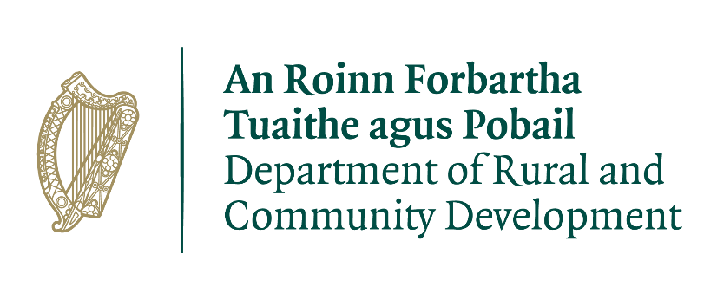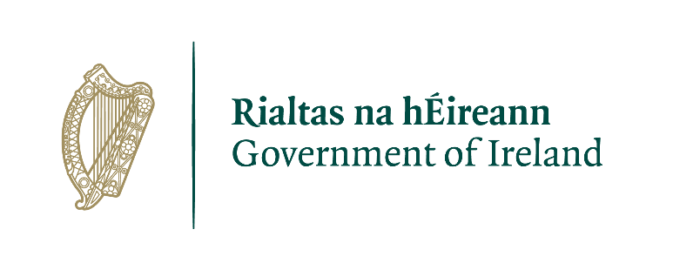
FOR OFFICE USE ONLY

Reference Number:

Date Received:

Date Stamp

LCDC recommendation:

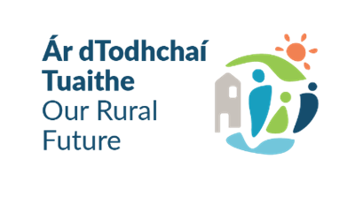
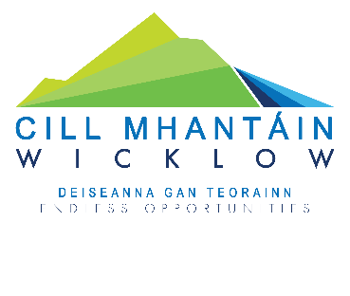
Women’s Group Name:

COMPLETED APPLICATIONS ARE TO BE RETURNED TO:

Wicklow LCDC,
Community, Cultural & Social Development,
Wicklow County Council,
County Buildings, Whitegates, Wicklow Town, Co. Wicklow. A67 FW96

OR SCANNED APPLICATIONS TO BE EMAILED TO:
lep@wicklowcoco.ie

By 4.00 p.m. on Friday 8th March 2024
CLOSING DATE WILL BE STRICTLY ADHERED TO.

ONLY FULLY COMPLETED APPLICATIONS WILL BE ACCEPTED. INCOMPLETE APPLICATIONS WILL BE RETURNED TO APPLICANT.

Please read the Application Guidelines for the ‘Local Enhancement Programme 2024’ before completing this form.

Department of Rural and Community Development
Local Enhancement Programme 2024
Ring-fenced fund for Women’s Groups

The Department of Rural and Community Development (“the Department”) has allocated funding of €1 million to support Women’s Groups across Ireland.

This is a ring-fenced fund under the Local Enhancement Programme 2024. The application process is being administered by Local Community Development Committees (LCDCs).

Applications for this funding can be made on this application form. Women’s Groups are eligible to apply, once they meet the LCDC’s qualifying criteria.

It envisaged that this funding would, in general, be allocated in a relatively equal manner across Women’s Groups that submit valid applications.

TERMS AND CONDITIONS

- The ring-fenced funding under the Local Enhancement Programme will support Women’s Groups, particularly in disadvantaged areas, to carry out necessary repairs and improvements to their facilities and purchase equipment.
- This is a capital funding scheme. The scheme does not provide funding for the pay or employment of staff, or towards current ‘operating’ costs such as utility bills, etc.
- The information supplied by the applicant Women’s Group must be accurate and complete.
- Inaccurate or incomplete information may lead to disqualification and/or the repayment of any grant made.
- All information provided in respect of the application for a grant will be held electronically. The Department reserves the right to publish a list of all grants awarded on its website.
- The Freedom of Information Act applies to all records held by the Department and Local Authorities, including applications received and any additional correspondence related to the application.
- The application must be signed by the Chairperson, Secretary or Treasurer of the Women’s Group.
- It is the responsibility of each organisation to ensure that it has proper procedures and policies in place including appropriate insurance where relevant.
- Applications must be on the application form for 2024.
- Evidence of expenditure, receipts /invoices must be retained and provided to the LCDC, the Department of Rural and Community Development, the relevant local authority or any agent acting on their behalf if requested.
- Grant monies must be expended and drawn down from the LCDC by 31st December 2024.
- The Department of Rural and Community Development’s contribution must be publicly acknowledged in all materials associated with the purpose of the grant.
- Generally, no third party or intermediary applications will be considered.
- Late applications will not be considered.
- Applications by post should use the correct value of postage stamps and allow sufficient time to ensure delivery not later than the closing date of Friday 8th March 2024. Claims that any application form has been lost or delayed in the post will not be considered unless applicants have a Post Office Certificate of Posting in support of such claims.
- Breaches of the terms and conditions of the grants scheme may result in sanctions including disbarment from future grant applications.
- Please ensure the application form is completed in full. Incomplete applications will not be considered for funding.
- In order to process your application, it may be necessary for Wicklow County Council to collect personal data from you. Such information will be processed in line with the Local Authority’s privacy statement which is available to view on https://www.wicklow.ie/LivingYour-Council/Governance/Privacy-Policy

All questions on this form must be answered. Please write your answers clearly in block letters.

SECTION 1 – YOUR ORGANISATION

Name of Women’s Group

Address

Eircode
Municipal District (Circle as appropriate) | Arklow | Baltinglass | Bray | Greystones | Wicklow | Countywide

Contact name

Role in Group

Telephone number

E-mail

Website

Alternative Contact name

Alternative Telephone number

Alternative E-mail

Successful applications for funding under this programme will only be paid to the applicant organisation’s Bank Account. Please ensure you have your Bank Account details to hand if your application is successful.

Charitable Status Number (if applicable): ___________________________________________

Tax Reference Number (if applicable): _____________________________________________

Tax Clearance Access Number (if applicable): _______________________________________

Section 2: Description of Activities

Please provide a description of your Women’s Group, including information on the number of members, the organisational structure of your group, your group’s aims, whether there is any criteria for membership, the main focus of the activities of your group, etc.

SECTION 3 – Project Details

What will the funding be used for?

Amount being applied for: | €
Is this amount the partial or total cost of the purchase or works: | ☐Partial | ☐Total
If partial, please give the estimated total cost: | €

Important note: Please include supporting documentation, please contact lep@wicklowcoco.ie or 0404 20208 for information on the required supporting documentation.

Please state how your Women’s Group proposes to acknowledge the Department, LA or LCDC.

Note: Depending on the amount being applied for, this could be as simple as including an acknowledgement on notices/signs, or in any newsletters that are being produced locally.

SECTION 4 – DECLARATION

PLEASE NOTE BEFORE SUBMITTING:

ONLY FULLY COMPLETED APPLICATIONS WILL BE ACCEPTED.

INCOMPLETE APPLICATIONS WILL NOT BE CONSIDERED.

- I declare that the information given in this form is correct.

- I confirm I have read and fully understand the Terms and Conditions of this Programme (see page 2-3 of this form).

- I confirm that this grant application is submitted in acceptance of and compliance with the Terms and Conditions.

- I confirm that the Women’s Group does not have the funding to undertake the work/project without this grant aid or alternatively that with the grant the Group will now undertake a larger project which they otherwise would not be able to afford.
- I confirm that the applicant Group is tax compliant (if tax registered).

Name in block capitals (on behalf of Women’s Group):

Signature: (Please note a typed signature will not suffice)

Position held (block capitals):
Date:

The Department operates the Local Enhancement Programme through the Local Community Development Committees (LCDCs). It is a grant programme that provides funding to enhance facilities in disadvantaged areas. The Department committed to funding of €6 million for this programme. The €1 million fund which is ring-fenced for Women’s Groups is part of the €6 million.

